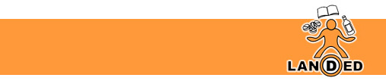

Understanding Substance Use in South Lanarkshire: Training for staff who work directly with young people.
The aim of this training is to increase the knowledge, understanding and confidence of practitioners working directly with young people in relation to substance use in South Lanarkshire. Training will also raise awareness of the Recovery Networks within South Lanarkshire
LANDED utilise a ‘harm-reduction’ approach within all our training inputs. We do not condemn or condone the use of substances but recognise young people may engage in risk-taking behaviours.

This training is targeted at staff members who work directly with young people.

Course Duration – 6 hours
Course Content
• What is substance use?

• ROSC – Recovery Orientated Systems of Care

• MAT & ORT

• The Recovery Network in South Lanarkshire

• Substance use related stigma.

• Cycle of Change - Impact of parental recovery on the child

• Different levels of substance use

• Drug knowledge

• Drugs & the law

For more information, or if you would like to book a training input for your staff team, please contact jacqui@landed.info

