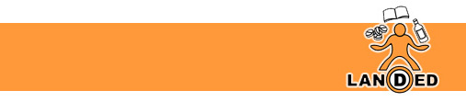

Understanding Substance Use in South Lanarkshire: Training for parents, carers, and family members.

LANDED Peer Education Service has been commissioned by South Lanarkshire ADP to deliver awareness raising training to parents, carers, and family members in South Lanarkshire. The training aims to increase the knowledge, understanding and confidence of family members in relation to substance use issues through a Lanarkshire lens.
Training will also raise awareness of the Recovery Networks within South Lanarkshire – their purpose, and how to access services if needed.
LANDED utilise a ‘harm-reduction’ approach within all our training inputs. We do not condemn or condone the use of substances but recognise young people may engage in risk-taking behaviours.
Course Duration – 3 hours

Course Content
- What is substance use?
- Drug categories
- Drugs in Lanarkshire
- Modern day drug deals
- A difficult conversation (CRAFT)
- Drugs & the Law
- South Lanarkshire Recovery Networks

For more information, or if you would like to book an input for your group, please contact jacqui@landed.info

